|  |  |
| --- | --- |
| Exp no: 04 | PAGE REPLACEMENT ALGORITHM |
| Date: |

# AIM:

# DESCRIPTION:

|  |  |
| --- | --- |
| EXP NO: 4(A) | FIRST IN FIRST OUT |
| DATE: |

# AIM:

# FIRST IN FIRST OUT PAGE REPLACEMENT ALGORITM:

# ALGORITHM:

# SOURCE CODE:

#include<stdio.h>

int fr[3];

void main() {

void display();

int i,j,page[12]={2,3,2,1,5,2,4,5,3,2,5,2};

int

flag1=0,flag2=0,pf=0,frsize=3,top=0;

for(i=0;i<3;i++)

{

fr[i]=

-1;

}

for(j=0;j<12;j++) {

flag1=0; flag2=0; for(i=0;i<12;i++) {

if(fr[i]==page[j]) {

flag1=1; flag2=1; break; }}

if(flag1==0) {

for(i=0;i<frsize;i++) {

if(fr[i]==

-1)

{

fr[i]=page[j]; flag2=1; break; }}}

if(flag2==0) {

fr[top]=page[j];

top++;

pf++;

if(top>=frsize)

top=0; }

display();

}

printf("Number of page faults : %d ",pf+frsize);

}

void display()

{

int i; printf("\n");

for(i=0;i<3;i++)

printf("%d\t",fr[i]);

}

# OUTPUT:

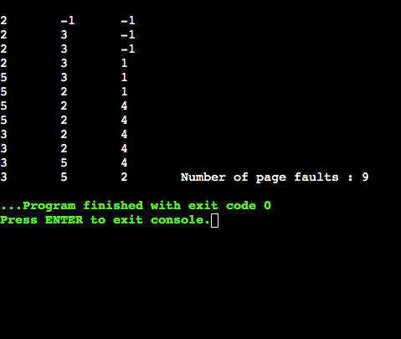

# RESULT:

|  |  |
| --- | --- |
| EXP NO: 4(B) | LEAST RECENTLY USED |
| DATE: |

# AIM:

# LEAST RECENTLY USED:

# ALGORITHM:

# SOURCE CODE:

#include<stdio.h>

int fr[3];

void main()

{

void display();

int p[12]={2,3,2,1,5,2,4,5,3,2,5,2},i,j,fs[3];

int index,k,l,flag1=0,flag2=0,pf=0,frsize=3;

for(i=0;i<3;i++)

{

fr[i]=-1;

}

for(j=0;j<12;j++)

{

flag1=0,flag2=0;

for(i=0;i<3;i++)

{

if(fr[i]==p[j])

{

flag1=1;

flag2=1; break;

}

}

if(flag1==0)

{

for(i=0;i<3;i++) {

if(fr[i]==

-1)

{

fr[i]=p[j]; flag2=1;

break; }}}

if(flag2==0) {

for(i=0;i<3;i++)

fs[i]=0;

for(k=j

-1,l=1;l<=frsize

-1;l++,k--

)

{

for(i=0;i<3;i++) {

if(fr[i]==p[k]) fs[i]=1;

}}

for(i=0;i<3;i++) {

if(fs[i]==0)

index=i; }

fr[index]=p[j];

pf++; }

display(); }

printf("\n no of page faults :%d",pf+frsize);

}

void display() {

int i;

printf("\n");

for(i=0;i<3;i++)

printf("\t%d",fr[i]);

}

# OUTPUT:

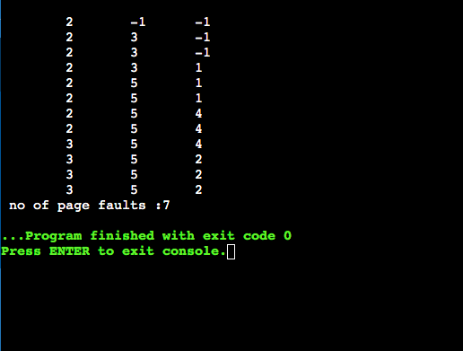

# RESULT:

|  |  |
| --- | --- |
| EXP NO: 4(C) | OPTIMAL PAGE REPLACEMENT |
| DATE: |

# AIM:

# ALGORITHM:

# SOURCE CODE:

#include<stdio.h>

int fr[3], n, m;

void

display();

void main()

{

int i,j,page[20],fs[10];

int

max,found=0,lg[3],index,k,l,flag1=0,flag2=0,pf=0;

float pr;

printf("Enter length of the reference string: ");

scanf("%d",&n);

printf("Enter the reference string: ");

for(i=0;i<n;i++)

scanf("%d",&page[i]);

printf("Enter no of frames: ");

scanf("%d",&m);

for(i=0;i<m;i++)

fr[i]=-1; pf=m;

for(j=0;j<n;j++) {

flag1=0; flag2=0;

for(i=0;i<m;i++) {

if(fr[i]==page[j]) {

flag1=1; flag2=1;

break; }}

if(flag1==0) {

for(i=0;i<m;i++) {

if(fr[i]==-1)

{

fr[i]=page[j]; flag2=1;

break; }}}

if(flag2==0) {

for(i=0;i<m;i++)

lg[i]=0;

for(i=0;i<m;i++) {

for(k=j+1;k<=n;k++) {

if(fr[i]==page[k]) {

lg[i]=k

-j;

break; }}}

found=0;

for(i=0;i<m;i++) {

if(lg[i]==0) {

index=i;

found = 1;

break;

}

}

if(found==0)

{

max=lg[0]; index=0;

for(i=0;i<m;i++)

{

if(max<lg[i])

{

max=lg[i];

index=i;

}

}

}

fr[index]=page[j];

pf++;

}

display();

}

printf("Number of page faults : %d\n", pf);

pr=(float)pf/n*100;

printf("Page fault rate = %f \n", pr); getch();

}

void display()

{

int i; for(i=0;i<m;i++)

printf("%d\t",fr[i]);

printf("\n");

}

# OUTPUT:

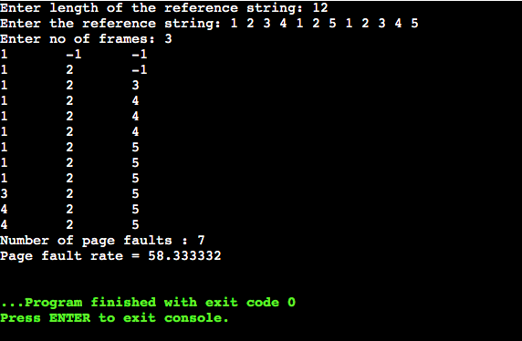

# RESULT: